**UNIVERSITI MALAYSIA PERLIS**

Penilaian Berterusan

**SMM30503 – Web Design & Development**

**[Rekabentuk & Pembangunan Web]**

**INDIVIDUAL ASSIGNMENT 1 (20M)**

**CO1:** Ability to develop HTML, CSS code and website designs.

**Outcomes:**

Student should be able to develop HTML Web design

**Tools:**

Adobe Dreamweaver, w3Schools, Adobe Photoshop, Adobe Illustrator, Visual Studio

**UR6321001 – New Media Communication**

**SMM30503 WEB DESIGN AND WEB DEVELOPMENT**

**INDIVIDUAL ASSIGNMENT 1 (20 marks)**

***CO1: Ability to develop HTML, CSS code and website designs.***

## HTML / CSS Assignment

**Overview:**

* For this assignment, you need to create a website using proper HTML and CSS
* **The Website must consist of a minimum three pages (3)**
* You may get the information/content of the website from outside sources.
* Although your website is only using HTML and CSS, make the website interesting, well organized, and easy to navigate.
* Note that you will be marked on both your content and design, and will lose marks for broken links, and html errors.
* Create a simple report consist of your website screenshot

**Possible Topic**

* Tourism
* **Fan Club**
* Movie review
* Pets
* Food
* Other you may choose

**Resources: To Help You Learn HTML and CSS**

* w3schools.com
* YouTube Tutorials

**Technical Criteria:**

* **On each page you should include a graphic title or logo.** **A title created by yourself in Photoshop is deserving of higher marks.**
* **You should lay out your content using <table> tag or <div> tags and position them as you see fit. The number of columns and exact layout is up to you.**
* **There should be titles for each page (in the head of your HTML documents)**
* **There should be paragraphs and heading text on each page, as well as images. (<p> and heading <h1>, <h2>, <h3> . . <h6>, <br> <img .... >**
* **There should be hyperlinks on each of the pages that provide navigation capabilities for your site. Each page to link to every other page.**
* **In addition, there should be at least one link to an external website. Use an absolute hyperlink, and have it open in a new browser tab or window.**
* **At least one of your images should link to another page or another site.**
* **You should include at least one numbered list or one bulleted list somewhere on at least one of your pages.**
* **You should include at least one table somewhere on one or more of the pages. (if the table used as a layout, it does not count)**
* **Beyond these requirements, feel free to include additional CSS to design your pages as you like!**

**REPORT**

The report is about how you complete the assignment. The step by step you took to complete the task. Screenshot the step and explain. Do it in proper way

**THE INDIVIDUAL REPORT GUIDELINES**

1. Introductions: Explains a bit about your choosing topic for your HTML website

2. Screenshot all the activities and explain each of the steps.

3. Attachments: includes all pages that you create

**VIDEO**

Submit together a short video/screen recorder show your HTML website are functioning and linkable to each other pages. You may make your video interesting by adding music and text. Make it look like an advertisement for your web

*(Please upload your video to your own YouTube channel or your own google drive and share the link)*

**SUBMISSION**

**XXXXXXXXXXX**

You also need to submit a Softcopy report to GoogleForm and eLearning.



**UR6321001 NEW MEDIA COMMUNICATION**

**SMM40303 - ANIMATION FOR INTEGRATED MEDIA**

**INDIVIDUAL ASSIGNMENT 1**

**HTML Website**

**(20 marks)**

**LECTURE NAME:**

**Dr. HABEE BULLAH AFFANDY**

**En. AMEER FUHAILI MOHAMAD HASHIM**

|  |  |
| --- | --- |
| **NAME** | **No. Matric** |
|  |  |

**CONTENT;**

***1. Introductions:***

***2. Process***

***3. Screenshots Sequences***

***4. Attachments***

1. **Introduction**

*Explain a what is your website and a brief concept of your website.*

1. **Process**

*Put a screenshot of your process of creating HTML. Explain the* ***key point*** *in your process,* ***does not*** *have to explain all the process HTML Code.*

*The explanation* ***can be in point form****. Example bellow;*

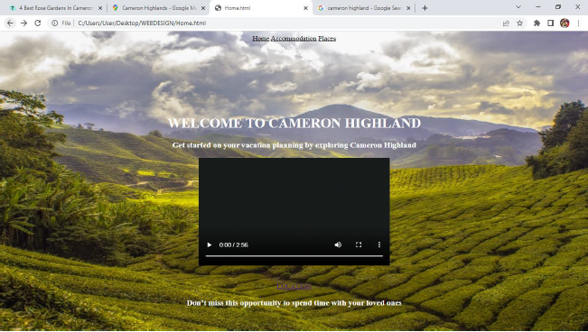

*Home Page*

The home page process is;

* Create a web template using table tag with 4 row and 1 column
* Create a background image using

<style>  
p {background-image: url('img_girl.jpg');}  
</style>

* Embed the video using the code

<iframe width="560" height="315" src="https://www.youtube.com/embed/L7mHvwO91TQ" title="YouTube video player" frameborder="0" allow="accelerometer; autoplay; clipboard-write; encrypted-media; gyroscope; picture-in-picture" allowfullscreen></iframe>

1. **Screenshot of All Pages**

*Paste your final Website’s pages Screenshots here*

**

**

**

1. **Attachment**

*Attach your link here*

*Youtube Link + QR Code*

*Google Drive Link*